Table of Contents
There is an urgent need for transparent evaluation of Moderna Spikevax BLA data: 2
Spikevax mRNA-1273 is a novel pharmaceutical entity. 2
Regulatory knowledge indicates very high risk with RNA/DNA products. 3
Moderna non-clinical studies had scientific improprieties, inadequate testing, and violations of regulatory guidelines. 5
The non-clinical studies for mRNA-1273 were not performed prior to human experiments. 5
The requirement for Good Laboratory Practice (GLP) compliance was met in only one animal study of Spikevax mRNA-1273. 6
The GLP reproductive toxicity study, in female animals only, demonstrated severe risks. 8
The risk of vaccine-induced antibody-enhanced disease was not excluded. 10
EXHIBIT 1. 11

There is an urgent need for transparent evaluation of Moderna Spikevax BLA data:
My affidavit attests to the following:
- mRNA vaccines represent an entirely novel class of biological products requiring thorough assessment of safety risks.
- Since approximately 1998, an extensive body of regulatory knowledge exists regarding gene therapy vaccine product risks, most recent guidance documents (2013, 2015 and 2020).
- Previously FOIA-released Moderna non-clinical (animal) data indicates numerous scientific improprieties, inadequate testing, and violations of enforceable regulatory guidelines in developing Spikevax vaccine.
- Therefore, it is imperative that clinical trial and other relevant data are made available for an independent review and assessment of Spikevax clinical development.

Spikevax mRNA-1273 is a novel pharmaceutical entity.
There had been no nonclinical or clinical data available for mRNA-1273 prior to 2020, and no other similar product was approved anywhere in the world at the time. The only previously approved product containing RNA is Onpattro. It contains small, non-coding RNAs called short interfering or siRNAs, typically 20-24 nucleotides in length. It is indicated for polyneuropathy due to an extremely rare, hereditary, and fatal “orphan disease” amyloidosis that is estimated to affect just 50,000 people worldwide. The mechanism of siRNA is different than that of modified or mRNA, which is a very large molecule (~3000-4000 nucleotides). As opposed to mRNA, siRNAs do not code for proteins, they “silence” or prevent translation of target genes.
Moderna’s mRNA-1273 formulated in lipid nanoparticle is an entirely novel chemical entity. While the regulatory opinion on this topic has not yet been disclosed for Moderna, the European Medicines Agency’s reviewers wrote the following opinion regarding Pfizer’s mRNA-LNP product’s novelty (see EMA Opinion document in Attachment):
“The modified mRNA in the COVID-19 mRNA Vaccine is a chemical active substance that has not been previously authorized in medicinal products in the European Union. From a chemical structure point of view, the modified mRNA is not related to any other authorized substances. It is not structurally related as a salt, ester, ether, isomer, mixture of isomers, complex, or derivative of an already approved active substance in the European Union.
The modified mRNA is not an active metabolite of any active substance(s) approved in the European Union. The modified mRNA is not a pro-drug for any existing agent. The administration of the applied active substance does not expose patients to the same therapeutic moiety as already authorized active substance(s) in the European Union.
A justification for these claims is provided in accordance with the “Reflection paper on the chemical structure and properties criteria to be considered for the evaluation of new active substance (NAS) status of chemical substances” (EMA/CHMP/QWP/104223/2015), COVID-19 mRNA Vaccine is therefore classified as a New Active Substance and considered to be new in itself.”
Moderna’s Spikevax is the same class of chemical entity and product, utilizing same design, same target antigen, similar lipid nanoparticle mechanism of delivery, and claims an identical mechanism of action as for the Pfizer’s product. Entirely novel pharmaceutical entity is typically considered the highest risk and requires thorough, non-abbreviated assessment in all phases of development.
Adding to the novelty and complexity of proper assessment, mRNA contained in the lipid nanoparticles in the Moderna vaccine is, in pharmacological terms, a prodrug. A prodrug is a medication or compound that after administration is metabolized (i.e., converted in the body) into a pharmacologically active drug (e,g., a metabolite). Often, the prodrug has no function other than delivering the active metabolite to the human body, hopefully to a specific location. It is the spike protein which is the active drug, and which is directly responsible for the immune response. However, the pharmacology and toxicology studies of the spike protein in animals or humans were not done as would normally have been required. This is the major fundamental error in the research and development of these COVID-19 vaccines and this oversight is directly responsible for the failure to predict the serious adverse drug reactions and mortality which have now been reported in association with these vaccines.

Regulatory knowledge indicates very high risk with RNA/DNA products.
The FDA publishes Industry Guidance documents describing regulatory knowledge and expectations for pharmaceutical manufacturers developing certain classes of products. Due to the innovative nature of the pharmaceutical research and development, Guidance documents are generally non-binding recommendations and the precise scope of each phase of development is negotiated by the pharmaceutical sponsor with the regulators. This process is supposed to consider available scientific, regulatory, and clinical (if other products in the class have been approved) knowledge about the product class, and it’s potential and known risks.
However, parts of the FDA Guidance are enforceable.
The FDA has been publishing guidance documents for cellular and gene therapies starting in 1998. Therefore, an extensive body of regulatory knowledge regarding this product class has been available for the past 20+ years, the most recent pre-covid pandemic ones being 2013 (Preclinical Guidance) and 2015 (Clinical Guidance).
The 2015 “Considerations for the Design of Early-Phase Clinical Trials of Cellular and Gene Therapy Products” lists potential of these products to cause serious safety issues, including, among many others:
- Death;
- Potential to promote cancer;
- Uncontrollable and irreversible expression of proteins;
- Genotoxicity;
- Reproductive harm;
- Potential for transmission to other individuals through “shedding”.
Both the manufacturers and regulators are expected to anticipate these risks and design preclinical and clinical testing programs to exclude or fully characterize the harms to humans before the product can be introduced on market.
Covid-19 vaccines utilize the same chemical methods, mechanism of action and manufacturing “platform” technology and its implementation as do gene therapies. In fact, Moderna’s products were classified as gene therapies prior to and even in 2020 per company’s own shareholder disclosures.
Regarding covid mRNA/DNA vaccines specifically, the FDA published “Development and Licensure of Vaccines to Prevent Covid-19” in June 2020. This guidance document is final, was implemented without prior public participation, and is intended to remain in effect for the duration of the public health emergency related to COVID-19 declared by the Secretary of Health and Human Services (HHS) on January 31, 2020, effective January 27, 2020.

Moderna non-clinical studies had scientific improprieties, inadequate testing, and violations of regulatory guidelines.
For COVID-19 vaccines, certain critical research and development activities were either not done at all, not done in a normal and logical sequential manner, or not done to established laboratory or manufacturing standards normally required by the pharmaceutical industry. The failure to study the toxicology of the spike protein in animal toxicology studies is an example of critical research which was not done. Other examples of the total failure to conduct critical research include the lack of properly designed carcinogenicity, mutagenicity, genotoxicity, and reproductive toxicological studies in appropriate animal species. In particular, the potential for reverse transcription of mRNA genetic material into an individual’s DNA was not investigated.
Documentation on Moderna’s non-clinical summaries and biodistribution studies from Module 2 of Spikevax BLA has been made available via FOIA. Several critical deficiencies, scientific improprieties, and data indicative of potential to cause severe harms to humans were identified. These risks were not excluded in these experiments, and the product proceeded to the human phases of testing and on market, where vaccine negative efficacy, and severe injuries have been reported in close association with vaccinations with Spikevax and for the entire class of mRNA/DNA vaccines,,. Note that product class effects are additional evidence of causation of the harms by the product.
Specifically, the following problems have been identified in Moderna’s non-clinical summaries package:

The non-clinical studies for mRNA-1273 were not performed prior to human experiments.
Based on the FDA Guidance, nonclinical safety studies were required for Moderna mRNA-1273 before initiation of “first-in-human” (FIH) clinical trials. This requirement is enforceable as the applicable law is cited in the guidance (21 CFR312.23(a)(8).
According to the Moderna HHS production, as well as FDA’s “January 30, 2022, Summary Basis for Regulatory Action – Spikevax”, the Investigational New Drug Application (CFR 21 Part 312) to conduct Phase 1 human trials was opened on February 20, 2020 (IND# 19635). It was opened on behalf of Moderna by the National Institutes of Health (DMID). The second IND for Spikevax was opened on April 27, 2020, for Phase 2 human trials (IND# 19745). It is not clear why two IND numbers exist for a single vaccine product and why the US Government owns one of them.
Based on this timeline, the FIH studies for Moderna were approved to proceed and initiated on February 20, 2020. According to the CDC, as of January 11, 2020, Chinese health authorities said they’ve identified more than 40 human infections as part of this outbreak that was first reported on December 31. The World Health Organization announced the preliminary identification of the novel coronavirus on January 9. The record of Wuhan-Hu-1 includes sequence data, annotation, and metadata from this virus isolated from a patient approximately two weeks prior. At the time, no animal studies were completed for mRNA-1273 and this non-clinical part of Moderna’s dossier could not have been reviewed properly by the FDA to inform the IND decision.
Furthermore, the package of the nonclinical studies consists of a scientifically dishonest and incomplete set of materials (see Exhibits):
- Irrelevant test articles used in many studies (other experimental mRNAs that have not been approved anywhere in the world). Note that Moderna claims “platform” technology, however no components of this “platform” were approved by any regulatory authority at the time of these studies;
- Non-GLP studies for mRNA-1273 – data cannot be verified, audited or relied upon for regulatory decisions;
- Studying only one gender of animals in biodistribution and reproductive toxicity assessments – thus major toxicity questions remain unanswered for human populations;
- Foregoing entirely several categories of safety toxicology studies, such as safety pharmacology, carcinogenicity, genotoxicity, biodistribution in females and assessment of reproductive toxicity in males;
- The single GLP-compliant study for mRNA-1273 (reproductive toxicity in females) found maternal toxicities and fetal malformations. Therefore, this is a reliably assessed extremely serious safety signal and should have been further evaluated. Instead, it was dismissed by opinion, with no data supporting it.
Therefore, the enforceable requirement for a scientifically rigorous dossier of nonclinical studies to be completed prior to FIH for a novel product was not met by Moderna.

The requirement for Good Laboratory Practice (GLP) compliance was met in only one animal study of Spikevax mRNA-1273.
Regarding the nonclinical assessments for Covid-19 Vaccines (2020) the FDA guidance states that:
- (P.7)“When needed to support proceeding to FIH clinical trials, nonclinical safety assessments including toxicity and local tolerance studies must be conducted under conditions consistent with regulations prescribing good laboratory practices for conducting nonclinical laboratory studies (GLP) (21 CFR Part 58). Such studies should be completed and analysed (sic) prior to initiation of FIH clinical trials. When toxicology studies do not adequately characterize risk, additional safety testing should be conducted as appropriate.”
Nonclinical safety assessments for Spikevax mRNA -1273 were required. Therefore, these safety assessments were required under the GLP standards. The materials obtained by FOIA from HHS contained 699 pages of nonclinical studies and test results that were used by the FDA for issuing the BLA for Moderna’s Spikevax mRNA-1273.
Studies included in the package contained summaries of experiments numerous experimental and unapproved mRNA products unrelated to Sars-Cov-2, covid illness, or mRNA-1273. These are inappropriate and irrelevant for the regulatory clearance of another unapproved experimental product.
Out of approximately 25 studies included in nonclinical program (See Exhibit 1), there was a single, non-GLP biodistribution study in male rats only, conducted at the Charles River facility in Canada. The study was for an irrelevant drug substance test article, mRNA-1674 and not Spikevax mRNA-1273, formulated in the lipid nanoparticle (LNP) claimed to be substantially similar to the Spikevax LNP formulation. No formulation data were included; therefore, validity of this claim cannot be assessed. This experimental product is a construct of 6 different experimental mRNAs studied for vaccination against cytomegalovirus in 2017 and never approved for market anywhere in the world. This study demonstrated distribution of the lipid nanoparticles throughout the entire body and accumulation in all major organ systems, except the kidney. This indicates, that if LNP is carrying the Spikevax mRNA-1273 it will likewise be distributed throughout the body and accumulate in the same organs.
Notably, the study assessed only male animals and not females, therefore no information about biodistribution in females was made available to the FDA, and specifically, no information about exposure differences or accumulation in female reproductive organs was ever obtained. The reproductive toxicology study, discussed below (part 3), while conducted in only females, did not make biodistribution measurements.
In the biodistribution study, high LNP concentrations were observed in lymph nodes and spleen and persisted in those organs at 3 days after the injection. The study was stopped before full clearance could be observed, therefore, no knowledge exists on the full-time course of the biodistribution. Other organs where vaccine product was detected included bone marrow, brain, eye, heart, small intestine, liver, lung, stomach, and testes. Given that the LNPs and mRNA-1647 were detected in all these issues, it is reasonable to assume that the LNPs carrying mRNA-1273 likewise would distribute in the same way, and therefore, the spike protein would be expressed by the cells in those critical organ systems with unpredictable and possibly catastrophic effects.
It appears that no additional biodistribution studies were conducted with the final implementation of mRNA-1273, and therefore it is unknown what proteins are expressed in the tissues and organs. Therefore, the mechanism of action of the product has not been fully demonstrated.
There was a single, non-GLP repeat dose toxicity study with mRNA-1273, however the study was not completed at the time of the FOIA production (April 2022). This study is titled "5 weeks (2 doses) repeat immunogenicity and toxicity study" and was conducted in rats.
There was a single GLP reproductive toxicity using mRNA-1273, however in the study only female animals were vaccinated. Males were not (discussed below, C).
The remainder of the package contained 10 primary pharmacology studies with mRNA-1273, however all were non-GLP (see Exhibit 1, Table 1) and 6 GLP repeat dose toxicity studies that used irrelevant test articles – other experimental and previously unapproved mRNAs (See Exhibit 1, Table 3), as well as in-vitro genotoxicity experiments that included only 2 separate components of the lipid nanoparticle formulation (SM-102 and PEG2000), but no other parts of the final product in its final formulation. Two in-vivo genotoxicity studies included used irrelevant test articles.
No carcinogenicity studies with final product formulation were conducted. There were no safety pharmacology assessments for any organ classes such as cardiovascular, CNS, liver, spleen, or other critical organ classes that were shown to have substantial accumulation of the lipid nanoparticles in the biodistribution study.
Therefore, the enforceable requirement for GLP studies with the correct test article in final commercially manufactured formulation has not been met in 24 out of the 25 studies. Furthermore, the studies have not excluded toxicity risks to major organ systems, and no additional studies to evaluate and exclude those risks were conducted prior to large scale administration of the product in human studies.

The GLP reproductive toxicity study, in female animals only, demonstrated severe risks.
The FDA Guidance for Covid -19 Vaccine development (June 2020) states:
- (P.7) “Use of COVID-19 preventive vaccines in pregnancy and in women of childbearing potential will be an important consideration for vaccination programs. Therefore, FDA recommends that prior to enrolling pregnant women and women of childbearing potential who are not actively avoiding pregnancy in clinical trials, sponsors conduct developmental and reproductive toxicity (DART) studies with their respective COVID-19 vaccine candidate. Alternatively, sponsors may submit available data from DART studies with a similar product using comparable platform technology if, after consultation with the agency, the agency agrees those data are scientifically sufficient.”
Moderna conducted Reproductive Toxicology study in pregnant and lactating rats using human dose of 100 mcg mRNA-1273 (described on p. -0001150 of the HHS FOIA production).
In this study, the reproductive toxicities were assessed for females only, males were not vaccinated. Therefore, no assessment of reproductive toxicities in males has been made at all.
The full study report was not included in the production. In the narrative summary of the findings, Moderna wrote:
“High IgG antibodies to SARS-CoV-2 S-2P were also observed in GD 21 F1 fetuses and LD 21 F1 pups, indicating strong transfer of antibodies from dam to fetus and from dam to pup.”
Safety assessments in the study appear to be very limited, however, the following findings are described by Moderna:
The mothers lost fur and appetite after vaccine administration, and it persisted for several days. There is no information on when it was fully resolved since the study was terminated before this could be assessed.
In the rat pups, the following skeletal malformations were observed:
“In the F1 generation [rat pups], there were no mRNA-1273-related effects or changes in the following parameters: mortality, body weight, clinical observations, macroscopic observations, gross pathology, external or visceral malformations or variations, skeletal malformations, and mean number of ossification sites per fetus per litter. mRNA-1273-related variations in skeletal examination included statistically significant increases in the number of F1 rats with 1 or more wavy ribs and 1 or more rib nodules. Wavy ribs appeared in 6 fetuses and 4 litters with a fetal prevalence of 4.03% and a litter prevalence of 18.2%. Rib nodules appeared in 5 of those 6 fetuses.” (See Exhibit 2).
The skeletal malformations were temporally associated to the days when highest toxicity was observed in the mothers: “Maternal toxicity in the form of clinical observations was observed for 5 days following the last dose (GD 13), correlating with the most sensitive period for rib development in rats (GDs 14 to 17)”.
The FDA included the following statement in the Basis for Regulatory Action Summary document (Section 4: Non-clinical Reproductive Toxicology, p.14):
“No vaccine-related fetal malformations or variations and no adverse effect on postnatal development were observed in the study. Immunoglobulin G (IgG) responses to the pre-fusion stabilized spike protein antigen following immunization were observed in maternal samples and F1 generation rats indicating transfer of antibodies from mother to fetus and from mother to nursing pups.”
The basis for agency’s dismissal of the risk of skeletal malformations in the vaccinated rat offspring is not clear, given Moderna’s admission of statistical significance of this signal, GLP compliance of the study, as well as temporal association with the highest levels of antigen expression in the mothers.
In summary, the vaccine-derived antibodies transfer from mother to child. It was never assessed by Moderna whether the LNPs, mRNA, and spike proteins transfer as well, but it is reasonable to assume that they do due to the claimed mechanism of action of these products. This should have been tested, and risks to the child should have been assessed, as the baby’s major metabolizing organs, such as the liver, are very small. Dose finding studies for Moderna are still ongoing and incomplete. An overdose through transfer and high expression of spike protein could pose serious life-threatening risks to a baby. This was never disclosed to the pregnant and breastfeeding women who were being coerced into receiving these injections.

The risk of vaccine-induced antibody-enhanced disease was not excluded.
The FDA Guidance for Covid -19 Vaccine development (June 2020) states:
- (P.8) “Current knowledge and understanding of the potential risk of COVID-19 vaccine associated ERD [Enhanced Respiratory Disease] is limited, as is understanding of the value of available animal models in predicting the likelihood of such occurrence in humans. Nevertheless, studies in animal models (e.g., rodents and non-human primates) are considered important to address the potential for vaccine-associated ERD.”
Prior to 2020, Moderna had not been able to bring any products to market, and few of its development candidates ever progressed to clinical trials in humans. None had reached the regulatory approval phase.
Notably, its mRNA-based vaccines were associated with the antibody-enhancement (ADE) phenomenon. ADE and ERD both describe the same clinical concern – worsening of the disease severity after vaccination for the disease. One such example includes Moderna’s preclinical study of mRNA-based zika vaccine in which vaccinated mice all “uniformly [suffered from] lethal infection and severe disease due to antibody enhancement.” The scientists were able to develop a vaccine type (IgEsig-prM-E FL) that generated protection against Zika and “resulted in significantly less morbidity and mortality,” although all versions of the vaccine unequivocally led to some level of ADE. By day 5, survival rate for mice vaccinated with IgEsig-prM-E FL dropped to 80%, meaning 20% of the vaccinated mice had died due to ADE induced by the vaccine.
The Primary Pharmacology section in the HHS production of Moderna’s nonclinical studies (2.4.2 Pharmacology, Table 1) included 10 studies evaluating immunogenicity, protection from viral replication (declared mechanism of action), and to evaluate potential for vaccine-associated enhanced respiratory disease. These studies included the correct test article (mRNA-1273), however, all were non-GLP compliant. The results of these studies are briefly summarized in the text of the document package; however, the study reports are not provided.
On p.-000150, Moderna stated that “there were no established animal models” for SARS-Cov-2 virus due to its extreme novelty. In the next sentence, it appears that despite the extreme novelty of the virus, Dr. Ralph Baric at the University of North Carolina at Chapel Hill possessed an already mouse-adapted SARS-Cov-2 virus strain and provided it for some of the Moderna’s experiments.
Elsewhere, on p.-0001468, Moderna stated that the EDR concern was triggered by preclinical work on SARS-CoV and MERS-CoV vaccines, among others – so it seems the company is contradicting its own statements about lack of preclinical models of SARS. While discussing the ERD risk, Moderna stated that their own study results were unreliable due to the invalidity of the assays and absence of the positive control in their experiments: “As SARS-CoV-2 neutralization assays are, to this point, still highly variable and in the process of being further developed, optimized and validated, study measurements should not be considered a strong predictor of clinical outcomes, especially in the absence of results from a positive control that has demonstrated disease enhancement”.
Therefore, the risk of the ERD was not excluded, and not characterized in these studies.

EXHIBIT 1.
Tables summarizing the scope of the program from HHS Production of Moderna’s Nonclinical Studies.
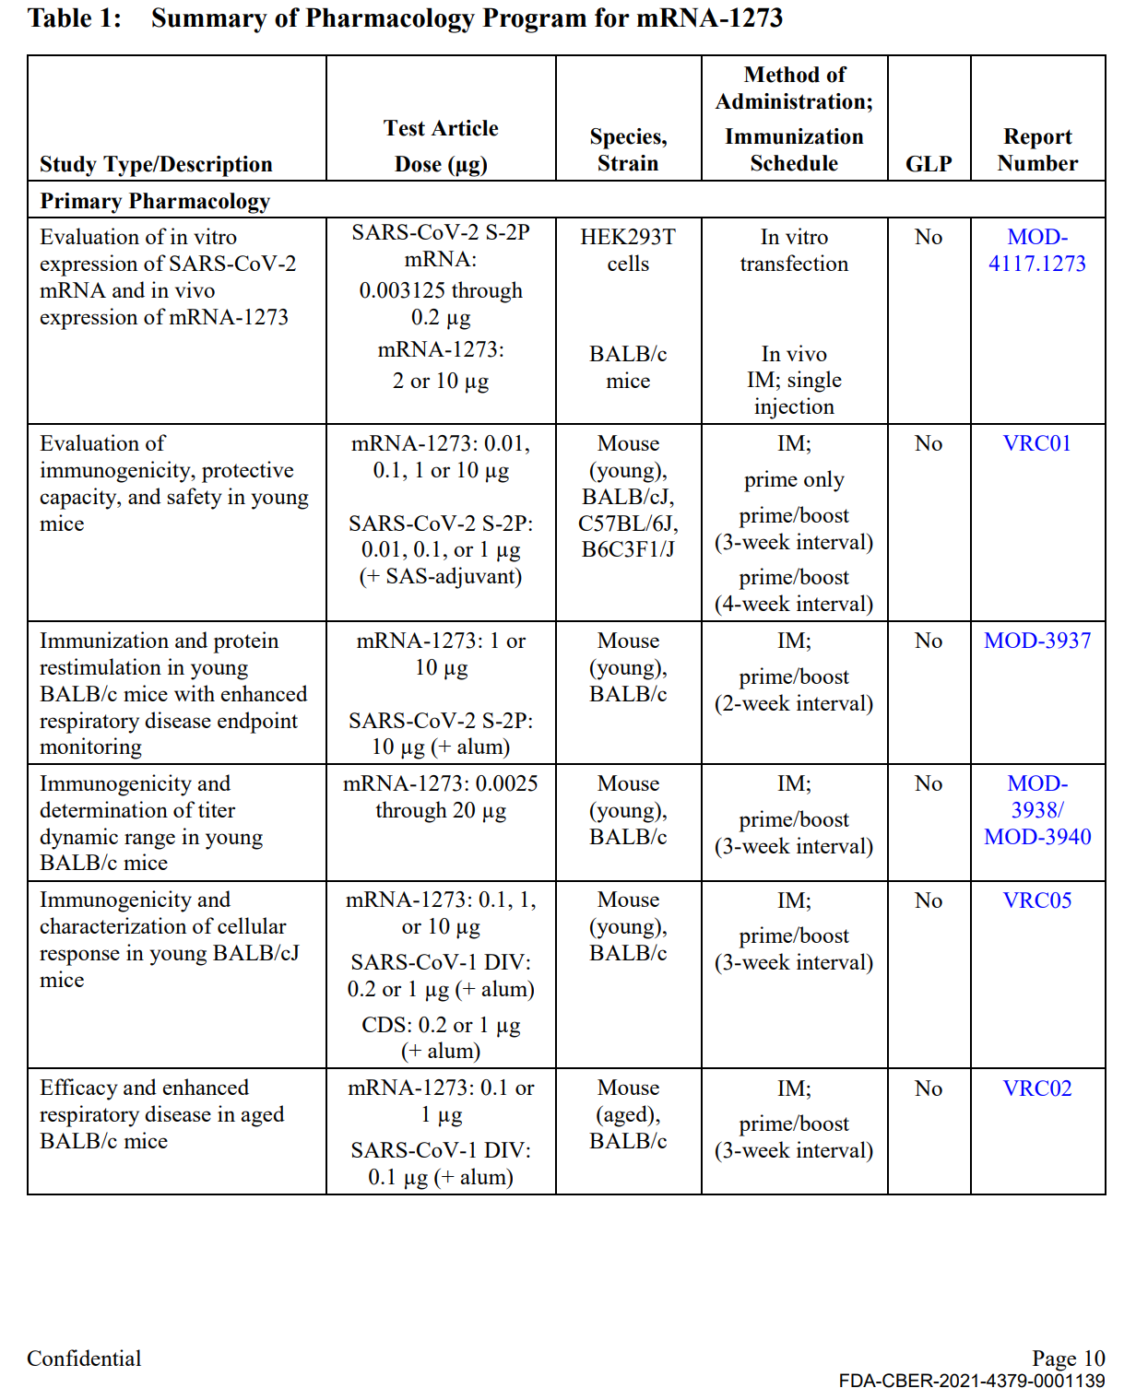

Table 1 continued:
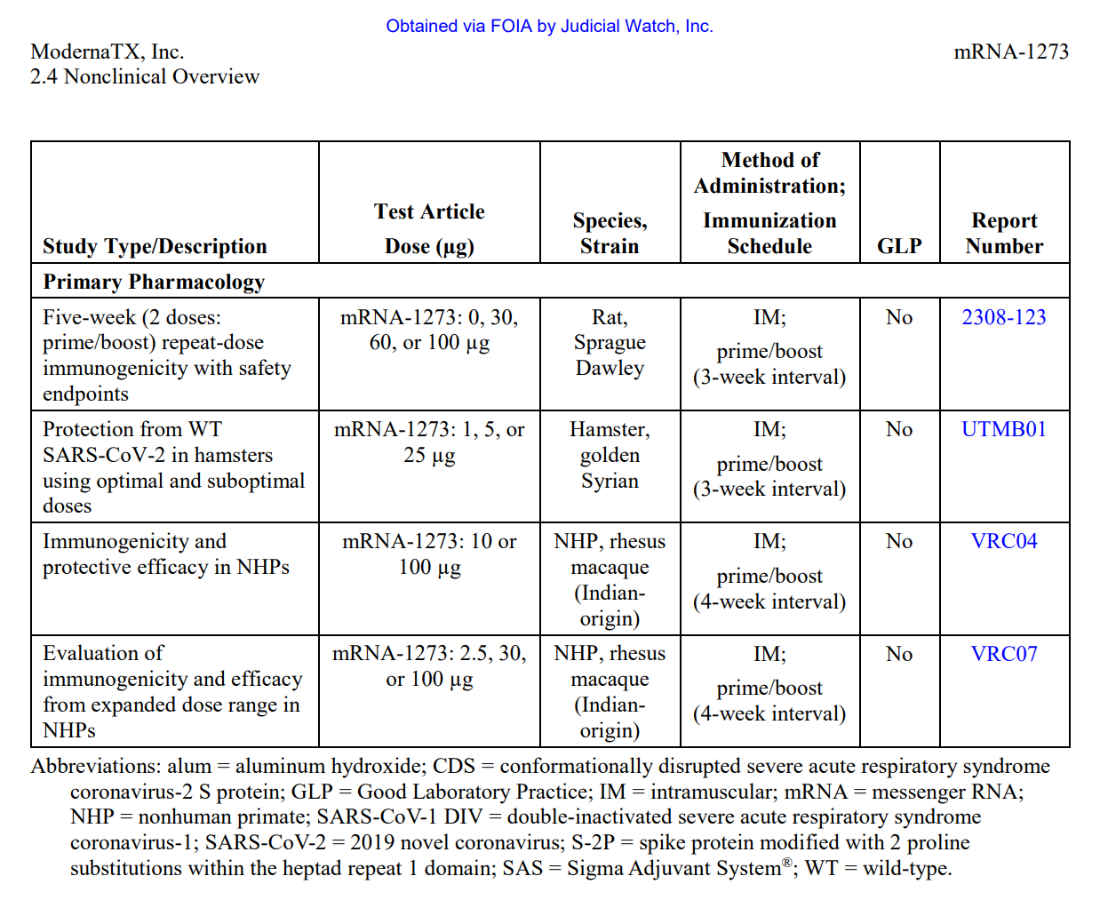
Table 2. Biodistribution.
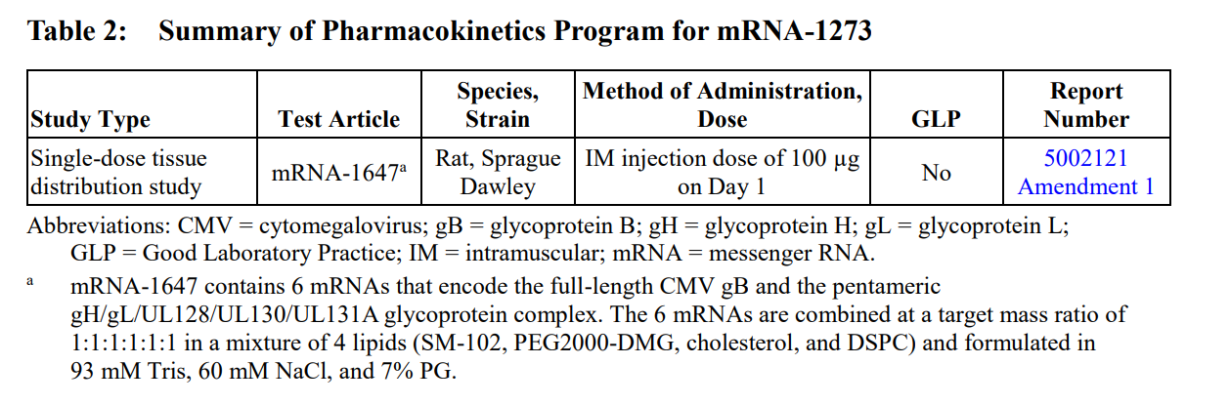

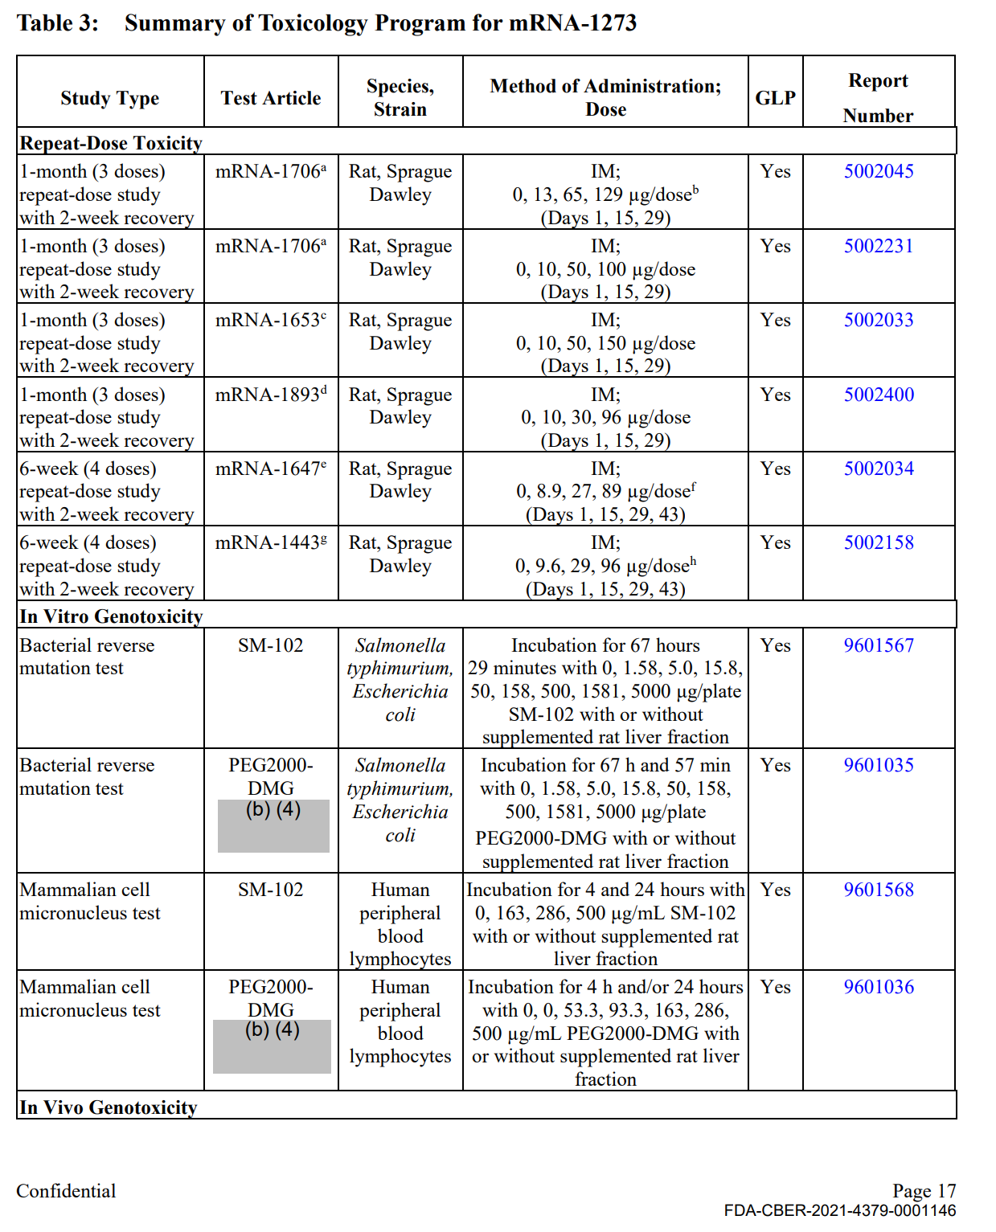

Table 3 continued.
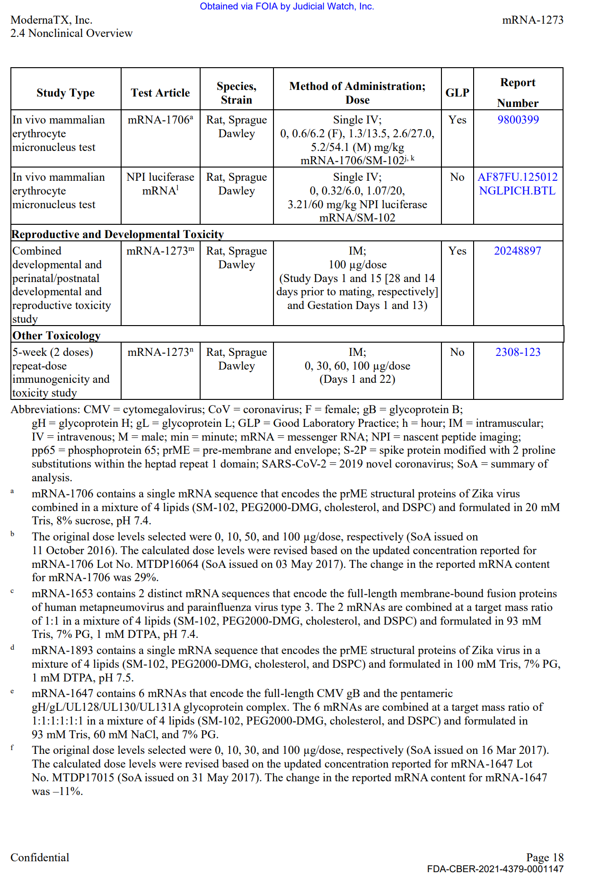
EXHIBIT 2.
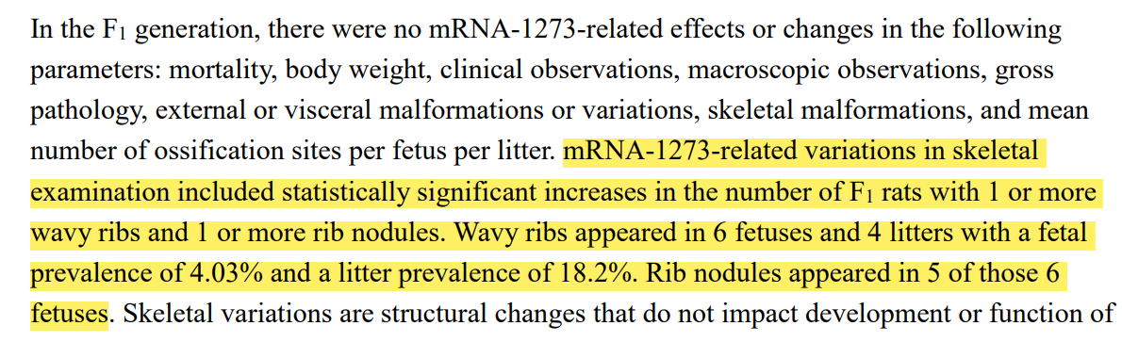
FDA-CBER-2021-4379-0001151

https://www.onpattro.com/
Alshaer W, Zureigat H, Al Karaki A, Al-Kadash A, Gharaibeh L, Hatmal, Aljabali AAA, Awidi A. siRNA: Mechanism of action, challenges, and therapeutic approaches. Eur J Pharmacol. 2021 Aug 15;905:174178. doi: 10.1016/j.ejphar.2021.174178. Epub 2021 May 24. Erratum in: Eur J Pharmacol. 2022 Feb 5;916:174741. PMID: 34044011.
Assessment report on the claim of new active substance (NAS) status of 5’capped mRNA encoding full-length SRAS-CoV-2 Spike protein contained in COVID-19 mRNA Vaccine BioNTech, Nov 11, 2020.
Cosentino M, Marino F. The spike hypothesis in vaccine-induced adverse effects: questions and answers. Trends Mol Med. 2022 Oct;28(10):797-799. doi: 10.1016/j.molmed.2022.07.009. Epub 2022 Sep 12. PMID: 36114089; PMCID: PMC9494717.
https://www.researchgate.net/publication/38104769_A_New_Classification_of_Prodrugs_Regulatory_Perspectives
https://www.fda.gov/regulatory-information/search-fda-guidance-documents/guidance-human-somatic-cell-therapy-and-gene-therapy
Note that many other rules and regulations apply to the development, manufacture, labeling and testing of biological products containing genetic materials and are expected to be considered by a BLA applicant for products containing genetic materials. This report addresses only preclinical development issues.
https://www.fda.gov/regulatory-information/search-fda-guidance-documents/preclinical-assessment-investigational-cellular-and-gene-therapy-products
https://www.fda.gov/media/106369/download
https://www.fda.gov/regulatory-information/search-fda-guidance-documents/development-and-licensure-vaccines-prevent-covid-19/
FDA FOIA Request 2021-4379; Judicial Watch, Inc. v. U.S. Department of Health and Human Services, 21-cv-2418. See Attachment.
See “Effectiveness of the Coronavirus Disease 2019 (COVID-19) Bivalent Vaccine”, medRxiv preprint doi: https://doi.org/10.1101/2022.12.17.22283625.
https://icandecide.org/v-safe-data/
https://vaersanalysis.info/
See “EvidentiaryDocument_COVID19NationalLevelHarm_01122022” in Attachment.
“Development and Licensure of Vaccines to Prevent Covid-19” June 2020, FDA.
https://www.fda.gov/media/155931/download
https://www.fda.gov/drugs/types-applications/investigational-new-drug-ind-application
https://www.fda.gov/media/155931/download
https://www.ncbi.nlm.nih.gov/pmc/articles/PMC5388441/figure/F3/

